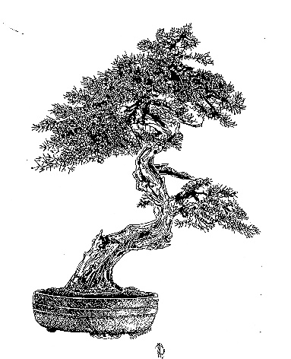

TEXAS BONSAI

A PUBLICATION OF THE LONE STAR BONSAI FEDERATION, INC.

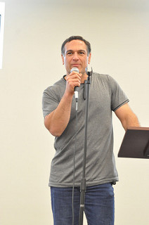
December, 2017

IN THIS ISSUE:
- President’s Message
- 2017 LSBF Convention in Review
- 2018 LSBF Convention Quick Notes
- Shohin Artlicle
- LSBF Board of Directors

Next LSBF Bonsai Convention-April 20-22,
2018
“Blooming Bonsai”
Hosted by the
Longview Bonsai Society

Bonsai Exhibit LSBF New Category:
Shohin
Hosting Club’s Special Category:
Forest or Group Planting

Howard Smith, LSBF President.
Bonsai Society of Dallas.

PRESIDENT’S MESSAGE:

Happy New Year! 2017 came and went faster than ever, but had many great bonsai moments. I am very happy with how the 2017 LSBF Convention went in Dallas - three fantastic world class artists under one roof working, teaching and advancing bonsai in Texas as LSBF friends all had fun learning and socializing. The Exhibit received many compliments and the vendor area provided many opportunities to acquire top level material and pottery. I am really looking forward to attending again in 2018 in Longview (for further details please look further in this newsletter and on the LSBF website: www.lonestarbonsai.org).

Our traveling artist for 2017, Jonas Dupuich, also was well received with many compliments throughout Texas and Louisiana and proved he is quite a talented and knowledgeable bonsai professional. I feel very privileged that he was available to spend the extensive time he did with our LSBF member clubs. Next year looks to be exceptional as well with Tyler Sherrod who has been back in the states going on two years after completing a 7-year apprenticeship in Japan under Shinji Suzuki.

The LSBF Board members continue to work steadily towards contributing to the improvement and advancement of bonsai in the region. We look for all opportunities to maximize the content and availability of educational events while being the umbrella which brings club members from our huge state and our neighbor Louisiana together. We have also updated our Board meeting format to include Skype sessions for the first time - providing better, more facile communication while leaving behind a much smaller environmental footprint. As of 2017, The Texas State Bonsai Exhibit (TTSBE) now plays an even closer role with LSBF with a non-voting representative at each Board Meeting.
The Board Officers will change positions in 2018, and I am happy to welcome Pete Parker of the Houston Bonsai Society as the new president of LSBF. Alan Walker, will be vice-president. Kevin Preston will remain on as treasurer and coordinator of the traveling artist visits (not an enviable position). Shannon Gilliland will remain on as secretary. It has been a pleasure working with the Board members for the last 2 years!

Keep warm this winter. See you all in Longview in April!
Howard Smith

2017 Convention in Review
“Making the Cut”
Lone Star Bonsai Federation &
Bonsai Society of Dallas

In April, 2017, Bonsai enthusiasts from all over Texas and surrounding States gathered at the Sheraton-North Dallas for the 34th LSBF Bonsai Convention. Over 80 registrants and 30 day observers came for the workshops, demonstrations, raffles, auction, vendors, lectures, and the bonsai exhibition.

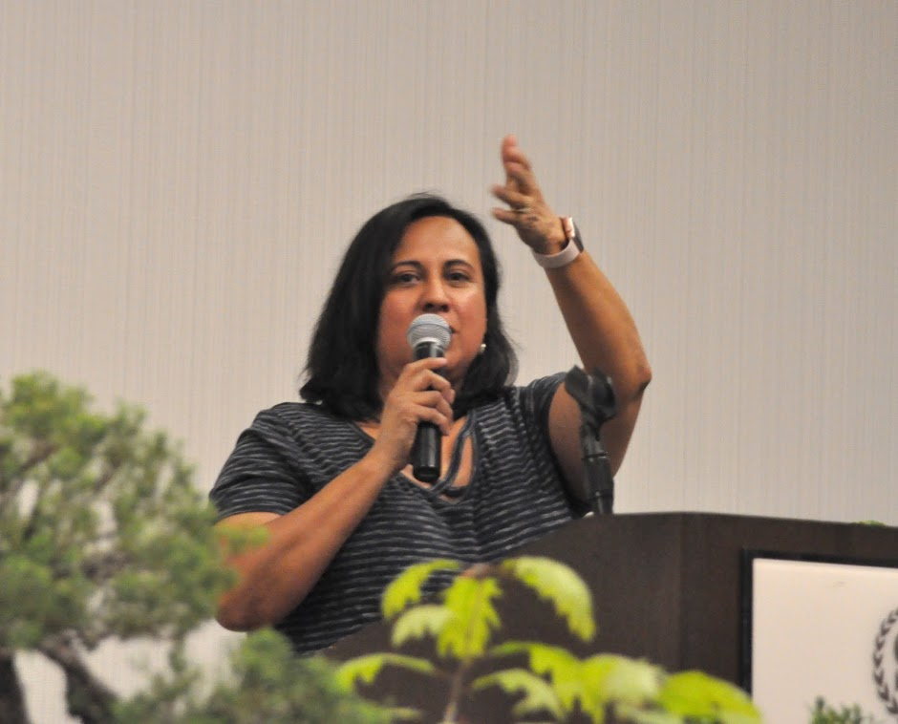
Sylvia Smith, Convention Chairman, welcomes everyone to Dallas.

The guest artists were Bjorn Bjorholm, Diasako Nomoto, and Jaun Andrade. The artists put on 3 workshops apiece, a demo each, and separate critiques of the Exhibit. The convention also featured a lecture by Michael Ryan Bell, a self-taught expert on Japanese pottery and a vendor as-well. Howard and Sylvia Smith also gave a lunch-time lecture.

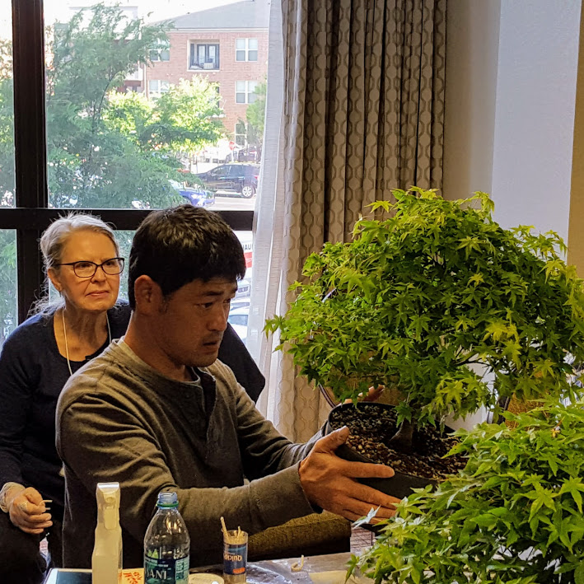
Diasako Nomoto conducting a Japanaese Maple workshop.

The Dallas Convention continued the Talent Contest introduced the previous year at the Corpus Christi Convention. Basically, a three-person tag team relay contest to initially style a raw tree. 1st place prize of a $200 Joshua Roth gift certificate each went to a team from the Houston Bonsai Society. 2nd place prize of a $100 Joshua Roth gift certificate went to another team from the Houston Bonsai Society. The Dallas club thanks Hurley Johnson for organizing and handling the Contest.

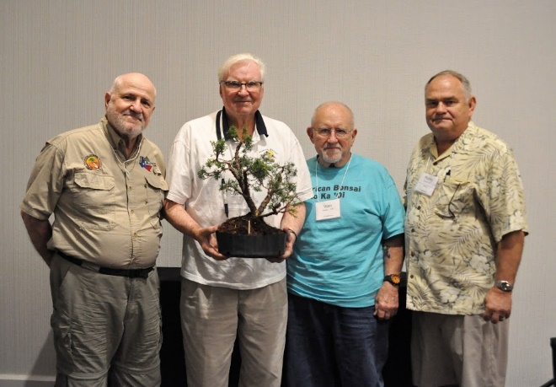
Winning Talent Team from Houston Bonsai Society: Ken Credeur, Clyde Holt, Vern Maddox. Hurley Johnson, presenter & organizer of the event.

Bjorn Bjorholm advises the styling of a shimpaku juniper during a workshop.

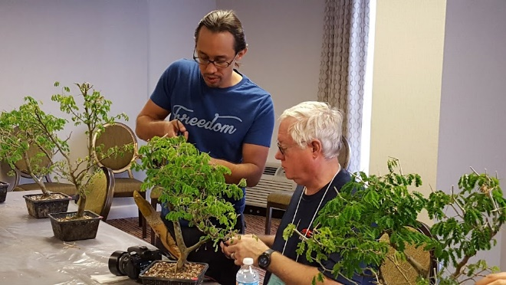
Juan Andrade shares his bonsai expertise at this workshop.

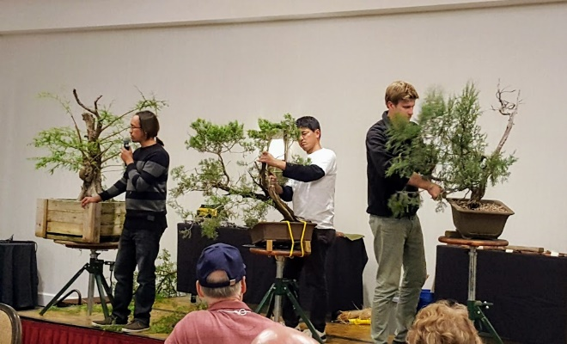
Triple Threat Bonsai Demonstration on Friday night.

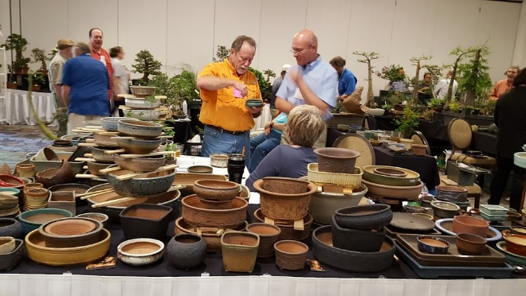
Bonsai pots for sale in the Vendors Area.

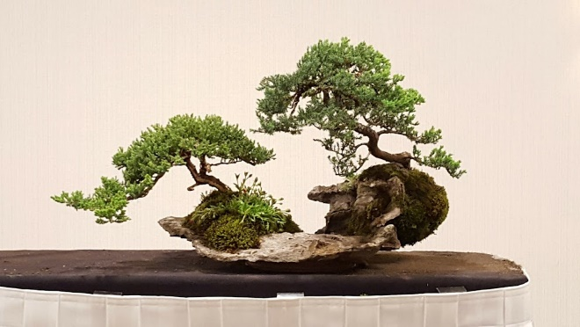
Completed demonstration of procumbens juniper group planting on a slab. Artists: Bjorn Bjorholm and Diasako Nomoto.

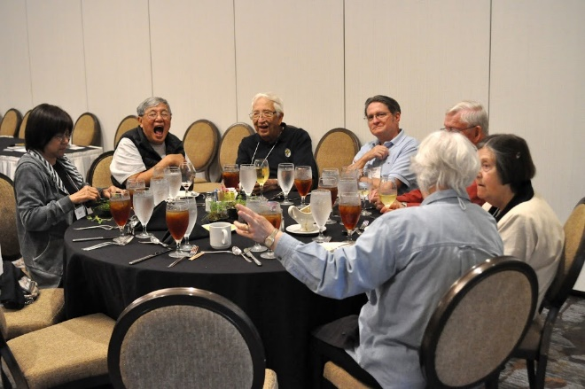
Meals become a good opportunity to socialize with friends from around the Federation.

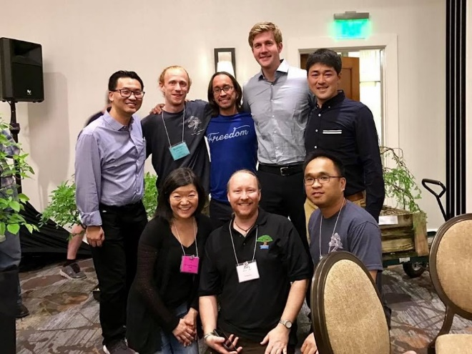
The Austin group takes advantage of a good photo opportunity. L-R, top: Simon Tse, Brandon Baldauf, Jaun, Bjorn, Diasaku. Bottom: May Lau, Joey McCoy, Quoc Hoang.
2017 Convention
Bonsai Exhibit
The Bonsai Exhibit is the gem of any convention. In Dallas, over 40 bonsai displays were presented with a high degree of professionalism. The Lone Star Bonsai Federation sponsors the “Excellence in Bonsai” recognition program to promote the advancement of bonsai art in our group. Six categories are recognized each convention. For a complete list of the categories and pictures of all 2017 winners, please see the LSBF website at lonestarbonsai.org.

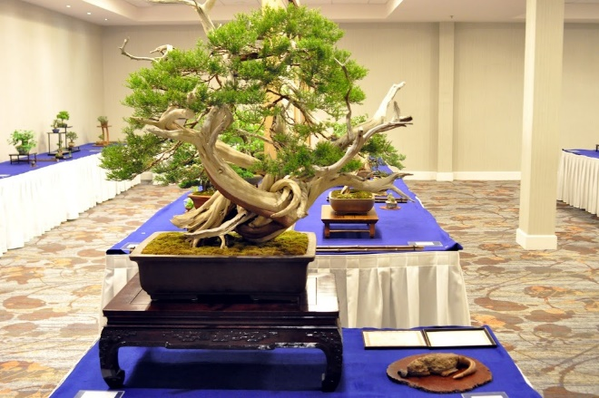
Best of Show: Ashe Juniper by Howard Smith., Bonsai Society of Dallas. Collected from Granbury, Texas.

Each convention, the hosting club selects a special one-time category for the awards. This year the host category was “Bonsai Display”.

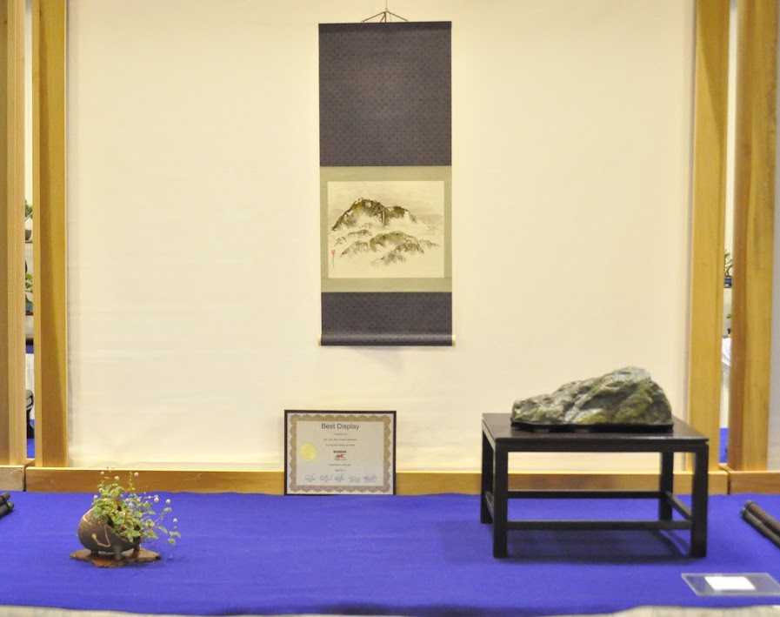Best Display: Vern Maddox of Houston Bonsai Soc
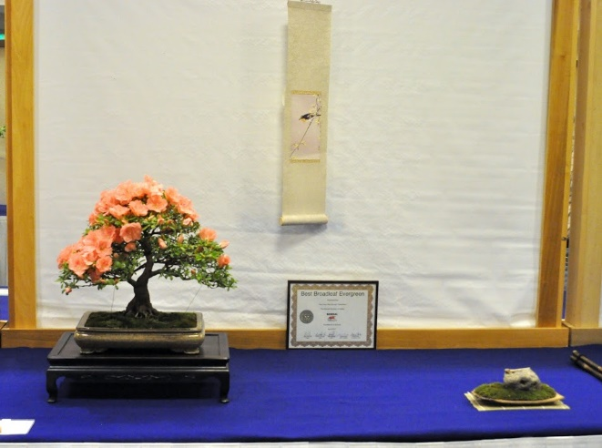
Best Broadleaf Evergreen: Azalea by Dr. Chuah,
Houston Bonsai Society

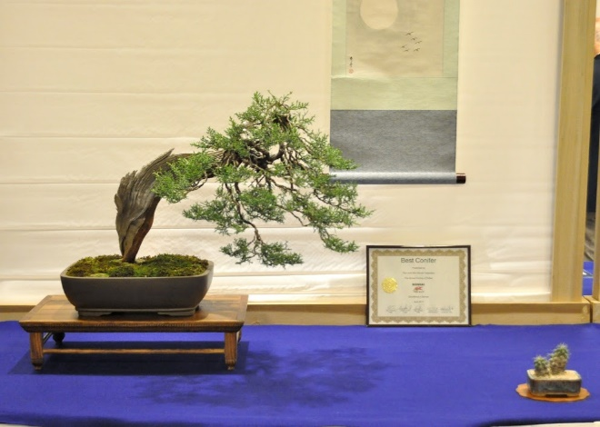
Best Conifer: One-seed Juniper by Mark Bynum,
Fort Worth Bonsai Society.

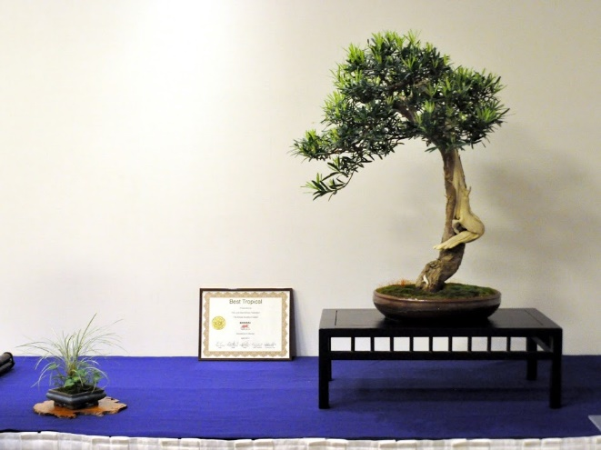
Best Tropical: Podocarpus Macrophyllus by Joey McCoy, Austin Bonsai Society.

2018 LSBF Convention
“Blooming Bonsai”
In Longview, Texas

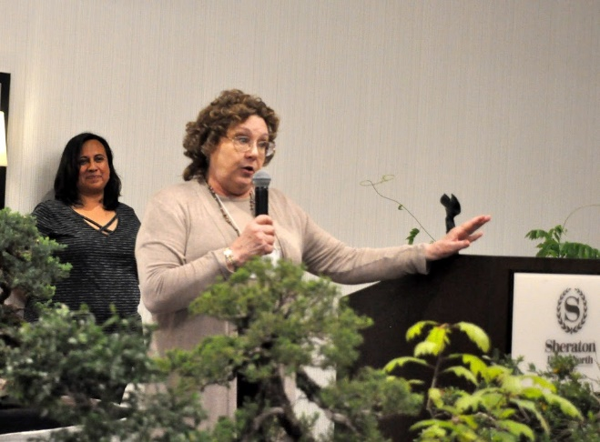
Shannon Gilliland, Chairman of the 2018 Convention, invites everyone to Longview for the next convention.

This will be the first bonsai convention held in Longview and the Longview Bonsai Society has been working diligently for the past 2 years to make this an exciting event.

The featured artists include “Bonsai Boon” Manakitivipart from California, Rodney Clemons from Georgia, and Mike Lane from Florida. Bob Specian, a local bonsai artist from Shreveport, LA, will also be conducting a workshop.Workshop materials include Brazilian Raintree, Lavender Star Flower, Pocomoke Crape Myrtle, and Cork Bark Oak, along with ‘bring your own tree’ workshops. There will also be workshops on Forest or Group Planting bonsai style, the featured host club’s category for the Exhibition.

The usual features of a vendors’ area, raffles, the LSBF Auction, Bonsai Demonstrations, LSBF Talent Contest, etc. will be included.

All information, details, and registration forms are located at the Lone Star Bonsai Federation website: lonestarbonsai.org
Shohin Class Bonsai General Guidelines
-by the Shohin Society of Texas

Editor’s Note: The LSBF Board has added the category of Shohin Bonsai to the “Excellence in Bonsai” Recognition Program at the LSBF Annual Bonsai Conventions. This new category debuts at the 2018 Convention in Longview. To fairly judge any class of bonsai, guidelines are needed to avoid any confusion and disappointment. The Shohin Society of Texas has provided these general guidelines as follows:
In the U.S., Japan and Europe shohin class bonsai are generally considered to have a maximum height of 8” (20 cm). While there are no ofﬁcial or exact classiﬁcations regarding bonsai sizes, some basic height guidelines are used as norms. Three examples: small- shohin up to 8”, medium- chuhin up to 18” and large- chumono up to 36" in height.
In addition to a 8” height limit for shohin bonsai, the proportion of the width of the trees canopy to the width of the pot should be taken into judging consideration. Those elements should compliment each other and project a feeling of balance and harmony. To achieve this, a pot’s width should, in general, be roughly 50% to 85% of the width of a trees canopy. The pot depth should also be taken into account. Some may say larger size pots are required to keep shohin bonsai alive in our Texas heat. Long experience has shown that smaller, proportional pots can be used without danger to the tree. There are care techniques to compensate for our challenging growing conditions.
The photograph that follows is of a shohin bonsai exhibit in Japan. The height of the top tree is 8” (20 cm). Please notice the balance and harmony achieved by the proportions of tree height to pot size for each tree.

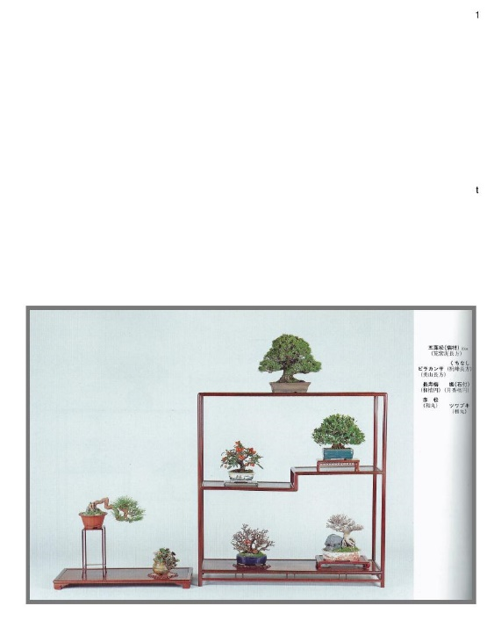

Please consider entering your shohin bonsai in the next LSBF Exhibition as an individual tree or as part of a display. See the LSBF website under tab “2018 Convention” for proper entry forms to the Longview Convention.

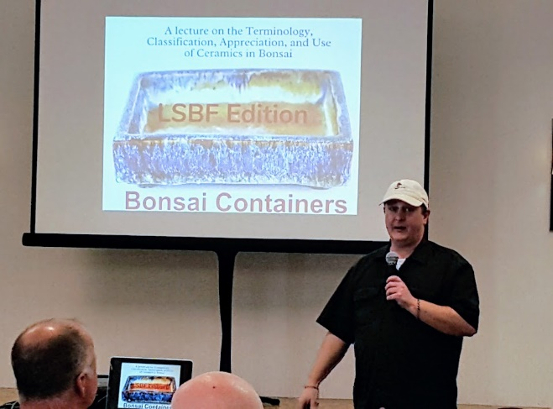
Michael Ryan Bell gives a lunch time lecture on Bonsai Containers at the 2017 LSBF Convention.

Officers:
2017 LSBF Board of Directors
Howard Smith, President Shannon Gilliland, Sec.
Bonsai Society of Dallas Longview Bonsai Society

Pete Parker, Vice-president Kevin Preston, Treasurer
Houston Bonsai Society San Antonio Bonsai Society
Delegates and Alternates:
Austin Bonsai Society:
Nan Jenkins, delegate lodenana@fastmail.fm
512-587-4506
Jonathon Wood, alt. Jonathan.WoodJs@gmail.com
512-695-2728

Corpus Christi Bonsai Club:
Yvonne Padilla, d el. myforest@sbcglobal.net
361-992-0009
Linda May, alternate pricemay3@gmail.com

Bonsai Society of Dallas:
Howard Smith, del. bonsaismiths@tx.rr.com
214-794-9109
Jerry Riley, alternate jafa625@gmail.com

Fort Worth Bonsai Society:
Mark Bynum, delegate mark.bynum12@att.net

Houston Bonsai Society:
Terry Dubois, delegate tdubois1@comcast.net
Pete Parker, alternate peteparkerbonsai@yahoo.com
832-656-0208

Lake Charles Bonsai Society:
Alan Walker, delegate awbonsai@bellsouth.net
Don Pearson, alternate

Longview Bonsai Society:
Shannon Gilliland, del. msgilliland@sbcglobal.net
903-235-2340
Mike Denholm, alternate mikden@cabletynx.com

Louisiana Bonsai Society:
Lowell Tilley, delegate ltilley@cox.net
225-252-6744

San Antonio Bonsai Society:
Kevin Preston, delegate hattie1@gvtc.com
830-438-2140
Donna Dobberfuhl, alt. two2views@yahoo.com

Shohin Society of Texas:
Dolores Plaisted, del. dolorespitd@gmail.com
281-338-5010
Alisan Clarke, alt alisanclarke@yahoo.com
512-327-3168
For all Convention Information:
LSBF Website: lonestarbonsai.org
Also find us on Facebook under: Lone Star Bonsai Federation

EDITOR’S NOTES:
Currently, I issue 2 Newsletters per calendar year; a pre-convention and a post-convention issue. These are distributed by email to your club’s delegate to the LSBF Board. The delegate is then to distribute the Newsletter on to the members. Each newsletter will also be archived on the LSBF Website at www.lonestarbonsai.org.
I am always looking for interesting articles to add to the newsletters. Articles can be specifically bonsai related or general information such as the history of your club.
Contact me with your thoughts.
Happy styling, Mark Bynum,
Fort Worth Bonsai Society,
Director of Publications
mark.bynum12@att.net

© Copyright 2017 by the Lone Star Bonsai Federation

The opinions expressed in articles and editorial materials in this publication are those of the authors and do not necessarily reflect the views of Texas Bonsai, its publishers, editors, and the Lone Star Bonsai Federation or its Board of Directors.

