LEGENDS OF THE LONE STAR BONSAI FEDERATION
This series of articles is a program by the LSBF Board to recognize the legends of our organization and will be featured in the LSBF Newsletter over the next few years. The legends are members of LSBF who have, in some way, impacted the advancement of bonsai art in our organization. As the articles are published they will also be archived on the LSBF Website as a permanent record.

John Miller By Sylvia Smith, Bonsai Society of Dallas

I don't think that there's anyone in Texas bonsai that is not familiar with the name of John Miller. John's Musing's have appeared in Texas Newsletters for so many years now that very few of us even know when the initial publication
began. He is one of the first members of the Bonsai Society of Dallas. At that time it was the first bonsai society in Texas and was appropriately called the Texas Bonsai Society, so one can easily say that John Miller IS Texas bonsai.
John was born and raised on a farm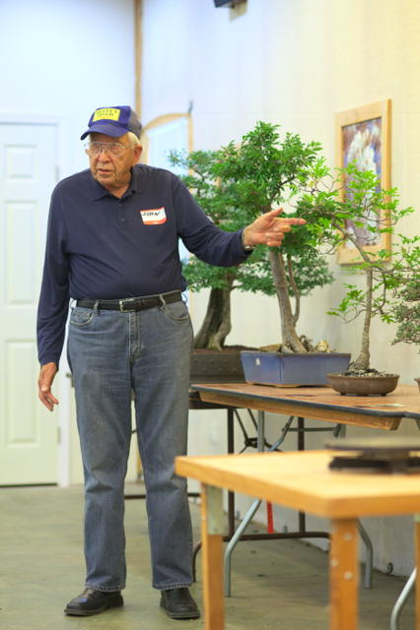 in Elms, Missouri. He was drafted into the army right after high school graduation and served his country from 1951 to 1953. It was during this time that he met and later married his wife Sue. John attended the Missouri School of Mines on the GI Bill and graduated with a degree in physics and a minor in electronics. His engineering career would involve many moves until finally procuring a job with Texas Instruments in Richardson, Texas. The nicest thing about these moves was that unlike a home garden, John could take his bonsai trees wherever he went, and that made him happy.

His first introduction to bonsai came after reading Yuji Yoshimura's book "The Japanese Art of Miniature Trees and Landscapes" in 1966. It wasn't long afterwards that John began to grow bonsai on his own. Then, in October of 1972, the local Dallas club held an exhibition at Fair Park. At last, John had found a group of people with the same interests as his. "I found people there I could talk to. I followed two mentors around the exhibit and listened to them critique the trees". "That's where I took my first workshop, an English boxwood which I still have today. You have to get your hands dirty in order to really learn!"
Shortly afterwards John went on his first digging trip off the country roads of Hwy 289, now known as Preston Road. Of course this just fired the flame and bonsai soon became a part of John's life. He was very active in the club learning as much as he could from the early pioneers of Texas bonsai Ted Guyger, George Gray, Arch Hawkins and Fred Meyer. He was exposed to demos and workshops with the great John Naka and studied for many years under the tutelage of Ernie Kuo. Somewhere in the middle of all that learning, he too became a teacher, offering his skills as an LSBF Artist, giving demos, workshops and writing informative articles of guidance for all bonsai enthusiasts.

But perhaps what we all most admire John for is his generosity. He loves to share his knowledge and insight with others freely. To my knowledge he has never charged any club for his programs and is always available at a meeting to give his expert advice on trees. He served many years as the BSD LSBF Delegate and never asked for a refund on gas expenses. Instead he quietly just gave of his time and experience to benefit his local clubs or anyone with an interest in bonsai simply because he too had been smitten with that same passion for trees 40 years ago.

John retired in 1994 and he and his wife Sue, who also grew up in the country, settled on an acreage near Farmersville, Texas, to be near family. The Millers have 5 children, 13 grandchildren, and 15 great-grandchildren. “We have our house and my trees, and I keep it mowed. No livestock of course, I didn’t retire to go to work.” Says the guy with hundreds of bonsai!

