LEGENDS OF THE LONE STAR BONSAI FEDERATION
This series of articles is a program by the LSBF Board to recognize the legends of our organization and will be featured in the LSBF Newsletter over the next few years. The legends are members of LSBF who have, in some way, impacted the advancement of bonsai art in our organization. As the articles are published they will also be archived on the LSBF Website (lonestarbonsai.org) as a permanent record.

Estella Flather
-interviewed by Mark Bynum

You may have seen her in past LSBF Conventions, manning her area in the vendors section selling bonsai jewelry as well as bonsai trees and accessories, as the owner of Artistic Plants. I first met Estella at a Fort Worth Bonsai Society bonsai exhibit in 2003 at the Fort Worth Botanic Garden Center. I bought a garden watering can and a small Calliandra (powder puff plant) from her to add to my beginners bonsai collection. This event was my first introduction to the broader world of bonsai and Estella, along with John Miller, made me feel that I could handle the tasks that the bonsai hobby would demand. I joined the Fort Worth Bonsai Society that afternoon.

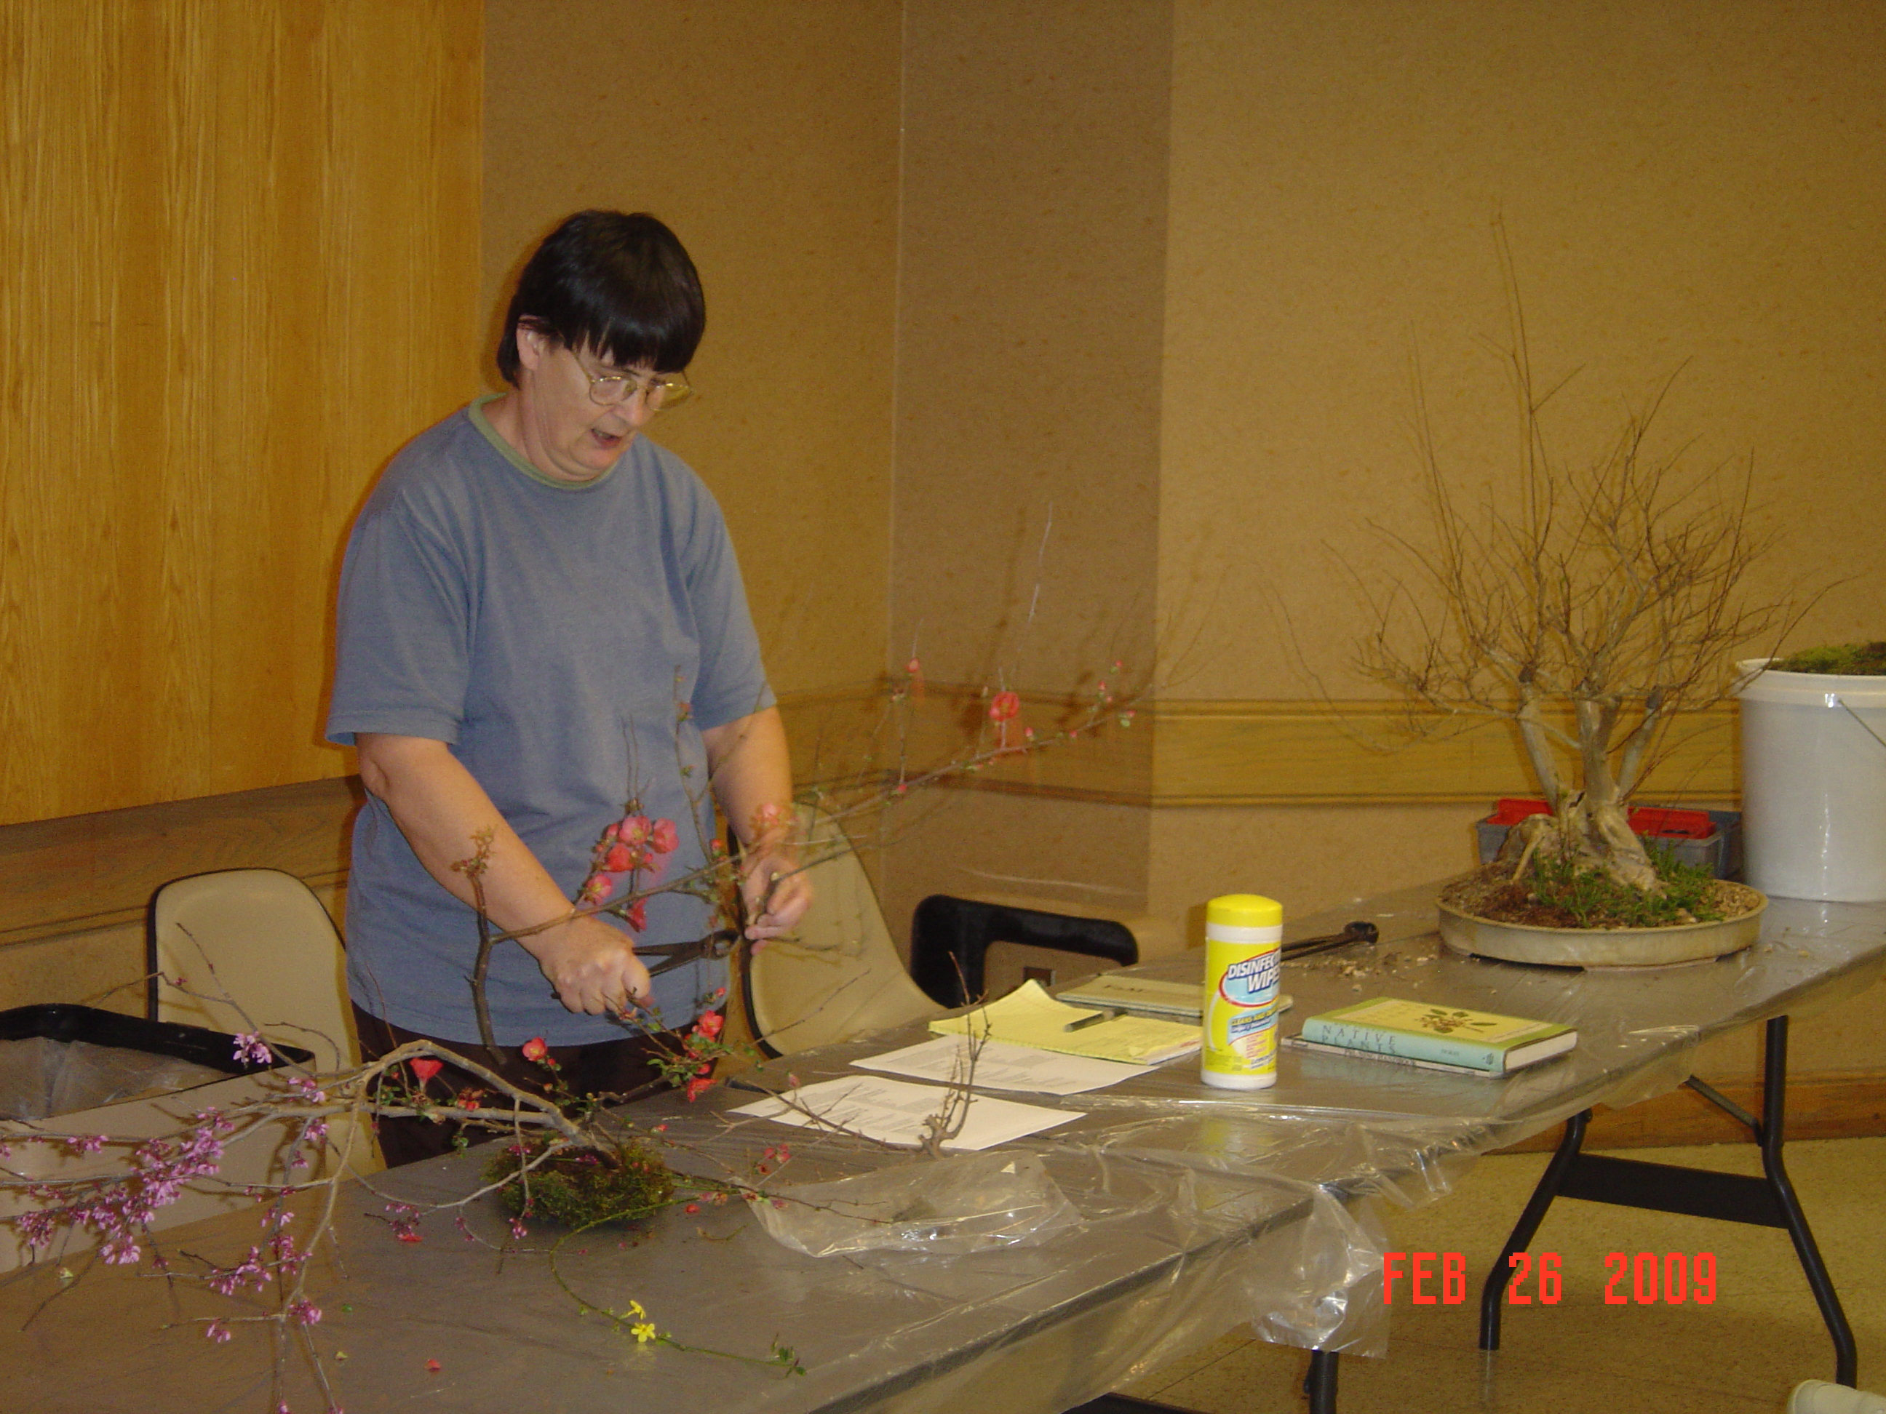
Estella Flather teaching a class at a bonsai meeting

Estella has grown plants all her life as her father was in the horticulture industry. He was a plant geneticist, who specialized in breeding annual plants such as petunias and snapdragons. As a child her family would grow annual plants to give away for Easter at church and she would help the ladies working in the greenhouse to fertilize flowers to create F2 hybrid petunias. Since junior high school she has been very involved in various types of crafts and began selling artwork at craft fairs in New Hampshire, Virginia, and Texas, wherever she was living at the time. While her husband was stationed at Fort Hood, Texas, she became interested in growing various types of miniature plants. She raised succulents for dish gardens and miniature tropical plants for terrariums that were sold at craft fairs in Austin. Around 1975 interest in miniature plants led to the study of bonsai, which quickly took over as her main focus. Growing up in California, her first memory of bonsai as a child was seeing a fascinating bonsai oak on the patio of the Huntington Public Library. She also remembers a Santa Barbara Bonsai Society exhibit at the county fair. She believes that bonsai is the perfect marriage of art and horticulture which dovetailed with her interest in crafts and growing plants.
Estella joined the Austin Bonsai Society around 1976 while at Fort Hood. Later, in 1983, while her husband was teaching ROTC at Tarleton State University in Stephenville, Texas, she joined the Bonsai Society of Dallas. To keep from driving so far to Dallas, Estella became one of the founders of the Fort Worth Bonsai Society where she is now an Honored Member. She has been president of the Fort Worth Bonsai Society for 4 years and has served as vice president of the Lone Star Bonsai Federation. She likes all types of bonsai plants and is self taught in the art. Her favorite bonsai artist is John Naka. As mentioned, Estella owns Artistic Plants and raises numerous bonsai plants at her nursery. (I have seen an Artistic Plants advertisement in Bonsai Today #2, now Bonsai Focus magazine, in August, 1989.) She continues to sell bonsai plants and related jewelry at the Gift Shop of the Japanese Gardens located in the Fort Worth Botanical Gardens as well as local craft fairs and local bonsai events.
Estella likes to tell a story about an encounter with Chase Rosade, a well-known bonsai artist and teacher. During an LSBF Convention, Chase was working on a yaupon holly. Because yaupon holly might not be familiar to him, Estella raised her hand and informed him that the branches a very brittle and he might need to be cautious while bending the branches. This, however, made him unhappy with her as he thought she was trying to show him up instead of just trying to save him some embarrassment if a branch should happen to break. Years later at a LSBF Convention, Estella was doing a demonstration on a yaupon holly. Chase was there and came up to her as she was carefully trying to change the direction of a branch and said, “Now be careful, those branches are brittle!” Estella replied, “Oooh, payback's a mother!” while trying not to laugh hard and break the branch.
The Fort Worth Bonsai Society often defers to Estella for horticultural expertise during our meetings. She lectures at least once per year at FWBS. Estella has taught a bonsai beginners class at the local junior college in the past. She also teaches a beginners class at the Garden Center when we can get enough interested people. She is most proud of all the people she has taught that are still bonsai enthusiasts. Her advice for new bonsai enthusiasts is, “Making a tree into a bonsai doesn't change the cultural requirements of the plant! Traditional bonsai are not indoor trees!”
Estella Flather has been a positive force in the advancement of the bonsai art in at least the North Texas area if not the State for 30+ years. She will no doubt be in attendance at future LSBF Conventions. Now that you know a little more, say hello next time you see her!

