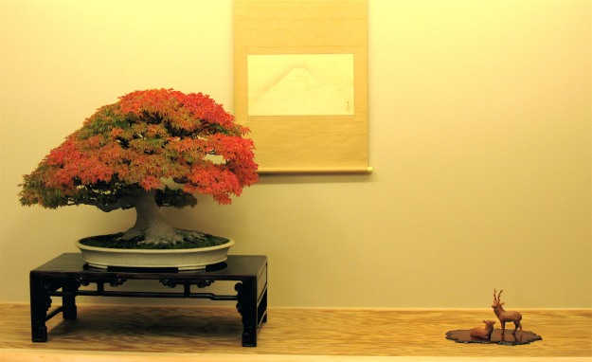
TEXAS BONSAI
A PUBLICATION OF THE LONE STAR BONSAI FEDERATION, INC.

SEPTEMBER, 2015
Formal Bonsai Display education will be a feature of the LSBF Educational Seminar in October. -by Matt Reel

President's Message

The Lone Star Bonsai Federation is a non-profit educational corporation in the State of Texas. Our founding mission is to “advance education in the aesthetic, historical, scientific, and horticultural features of the art of bonsai.” In addition, we are to “conduct meetings, exhibitions, and conventions to further the public's knowledge and interest in the art of bonsai.”
Because the normal club in the rotation for hosting the LSBF Convention in 2015 felt it was unable to handle the responsibilities adequately, leaving a hole in the convention sequence, your LSBF Board of Delegates decided to host an educational seminar in the

fall of 2015 to fill the gap and to accomplish our continuing mission. This will not be a full 3-day convention, but rather shortened to 1 ½ days with twp specific subjects and 1 artist. The focus is on bunjin (literati) style of bonsai and on formal bonsai display. Both of these subjects could use further study in our group and we have a trained teacher in Matt Reel. We chose Houston as the LSBF Seminar location due to its central location amongst the LSBF affiliated clubs. Demos, raffles, and an auction are included. The registration price is very reasonable and we have a special bunjin azalea workshop lined up to take part in or to observe. Do not miss this intense opportunity to further your skill in bonsai. Much more information, as well as a registration form are included in this newsletter. Also, see information on our Facebook Page (Lone Star Bonsai Federation) and our website (lonestarbonsai.org). Thanks to Howard Smith from the Bonsai Society of Dallas for chairing this event.
The touring artist for 2015, Owen Reich, visited the clubs in August. Plenty of workshops and demonstrations and lectures kept Owen busy for almost 3 weeks at 9 participating clubs. Your LSBF Board hopes you learned something from this artist who was well-versed in the horticultural aspect of the bonsai art. Thanks to Kevin Preston of the San Antonio Bonsai Society for coordinating this LSBF program.
In the last newsletter, I mentioned that the Board would be revitalizing the LSBF Artist Program. We have revamped the criteria for this program and are now in the process of signing up local artists from each club. This list will be available at the beginning of 2016 for clubs' use.
In January, 2016, there will be a new set of officers for the LSBF Board of Delegates, but we already have some work scheduled to be accomplished. The biggest task will be to rework our By-Laws to fit the new electronic age. Our By-Laws are close to 40 years old and need modernizing. We are also continuing to solicit neighboring states' bonsai clubs to join our Federation.
As always talk to your club's LSBF Board Delegate for any questions or to express an opinion. The Board will meet again in October at the Seminar in Houston. Any LSBF member is welcome to attend!

Happy styling,
Mark A. Bynum, President

WEBSITE for LSBF

Our website is located at:
www.lonestarbonsai.org

Currently the website has all the information for the October LSBF Educational Seminar along with Registration Forms.
Just click on the “Convention” tab
and then the
“ Convention Registration Form“ tab and then the
“Waiver & Show Form” tab

___________☼☼☼___________

This website is still under construction.
Please be patient as this will soon be our
main source of information for LSBF.
Add this site to your favorites!

Bunjin and Display:
The REEL Deal
☼☼☼
an LSBF Educational Seminar
October 9-10, 2015
beginning at 1:00 PM

Kingwood Community Center
4102 Rustic Woods Drive
Houston, TX 77345

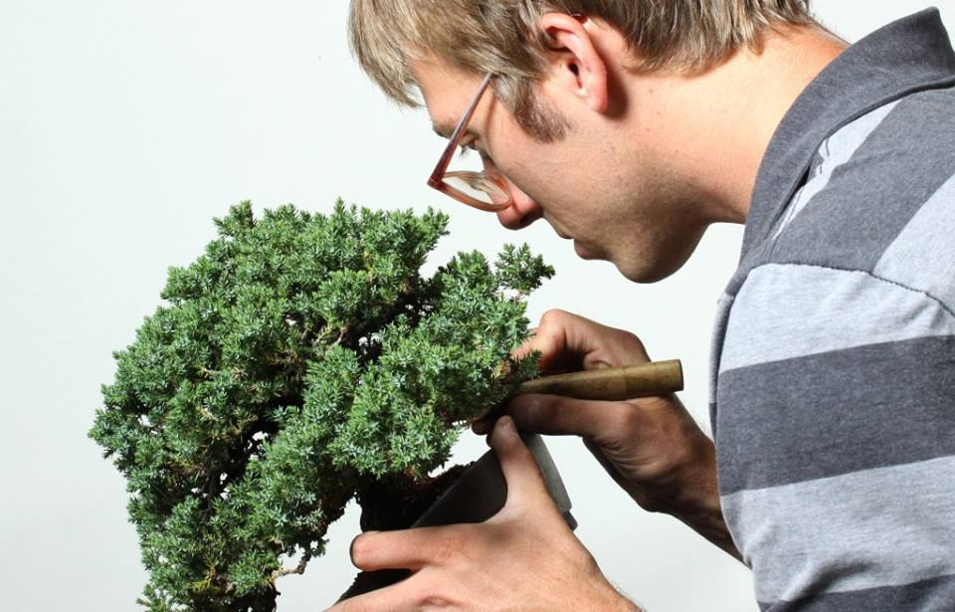
Matt Reel was an apprentice of Shinji Suzuki for over 7 years in Japan.

-from Howard Smith, Seminar Chairman:
“If we evaluate the strengths and weaknesses of a bonsai enthusiast I would bet that most of us are weak on the technicalities of creating good bunjin bonsai. I am really looking forward to Matt Reel’s guidance in this area. But I am equally looking forward to learning from him some of the intricacies of bonsai display. I’ve heard a few stories of Matt’s teacher Suzukisan’s attention to detail seemingly down to the molecular level of display. My understanding is that Matt, for 8 years, would set up numerous high level displays on a daily basis and if the scroll depicted a freshwater lake the figurine certainly better be a freshwater creature or freshwater water vessel. The size, shape, color and style of the stand had to suit the tree in many subtle ways, as well as the stand for the companion. All components in the display have to harmonize seasonally as well to really be acceptable and shine. I believe it is very important to learn all of these basic artistic, fundamental display concepts so that
we as Americans, and more specifically as Texans and Louisianians can start to incorporate our own regional flare with artistry and harmony. After Matt’s display discussions, I believe we will be much further on our way to having a ‘Texan’ display that would fit in any regional show in the world.”

Whether the demonstration trees fit your region or not, the thought processes and decisions made by the artist will apply to bunjin styling on any tree. It is guaranteed that you will learn something about bunjin and also display. Take advantage of this learning opportunity for a very reasonable price.
Registration is just $75 before September 9 with 2 meals included. There will be a raffle and an auction on Saturday. A small bunjin exhibition and a vendors area will run Friday and Saturday. Registration includes silent observing of workshops.

Seminar Schedule

Friday, Oct 9:
1 PM Workshop w/Matt Reel- Bring your own tree and tools. Could be bunjin or other. $75

1 PM Workshop w/David Kreutz- Bunjin potential satsuki azalea plants included. These azaleas come from Japan exclusively for this Seminar. Bring tools, wire, etc. $130

1 PM New Talent Event, Hurley Johnson, host- 1 person from each club eligible to enter.

5:30 PM Dinner- Announcements

6 PM Bunjin Demonstration #1 w/Matt Reel- a very nice collected Rocky Mountain Juniper chosen for it's bunjin potential.

Saturday, Oct 19:
8:30-9:45 AM Display Lecture #1 w/Matt Reel- Formal bonsai display

10:15-11:30 AM Display Lecture #2 w/Matt Reel- Bunjin and display critique of exhibition.
11:30-2:30 PM Lunch- Announcements, LSBF updates, New Talent winners, LSBF Exhibition Awards, 2016 LSBF Convention information, Auction and Raffle!

2:30-5:30 PM Bunjin Demonstration #2 w/Matt Reel-

6 PM- Close
Registration Form and Waiver Form are attached at the end of this newsletter.

Hotels close to the Seminar:
If the LaQuinta Hotel is full, here are a few other hotels close to the Seminar site. They range in price from $77 to $95 per night.

Courtyard Houston Kingwood
130 Northpark Plaza Dr., Kingwood, TX 77339
(281) 973-1790

Homewood Suites by Hilton
23320 US-59, Kingwood, TX 77339
(281) 358-5566

Holiday Inn Express and Suites
22675 US-59, Houston, TX 77339
(281) 359-2700

Candlewood Suites
291 Kingwood Medical Dr., Kingwood, TX 77339, (281) 713-8989

Comfort Suites
22223 US-59, Humble, TX 77339
(281) 359-4448

Hampton Inn
20515 Highway 59 North, Humble, TX 77338
(281) 446-4800

LEGENDS OF THE LONE STAR BONSAI FEDERATION
This series of articles is a program by the LSBF Board to recognize the legends of our organization and will be featured in the LSBF Newsletter over the next few years. The legends are members of LSBF who have, in some way, impacted the advancement of bonsai art in our organization. As the articles are published they will also be archived on the LSBF Website (lonestarbonsai.org) as a permanent record.

Estella Flather
-interviewed by Mark Bynum

You may have seen her in past LSBF Conventions, manning her area in the vendors section selling bonsai jewelry as well as bonsai trees and accessories, as the owner of Artistic Plants. I first met Estella at a Fort Worth Bonsai Society bonsai exhibit in 2003 at the Fort Worth Botanic Garden Center. I bought a garden watering can and a small Calliandra (powder puff plant) from her to add to my beginners bonsai collection. This event was my first introduction to the broader world of bonsai and Estella, along with John Miller, made me feel that I could handle the tasks that the bonsai hobby would demand. I joined the Fort Worth Bonsai Society that afternoon.

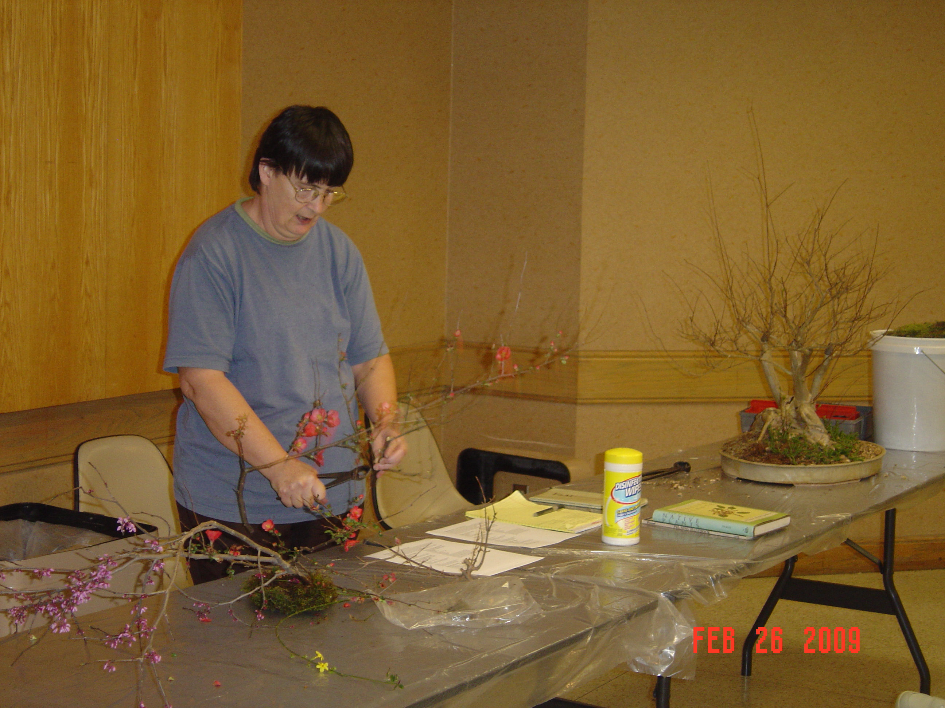
Estella Flather teaching a class at a bonsai meeting

Estella has grown plants all her life as her father was in the horticulture industry. He was a plant geneticist, who specialized in breeding annual plants such as petunias and snapdragons. As a child her family would grow annual plants to give away for Easter at church and she would help the ladies working in the greenhouse to fertilize flowers to create F2 hybrid petunias. Since junior high school she has been very involved in various types of crafts and began selling artwork at craft fairs in New Hampshire, Virginia, and Texas, wherever she was living at the time. While her husband was stationed at Fort Hood, Texas, she became interested in growing various types of miniature plants. She raised succulents for dish gardens and miniature tropical plants for terrariums that were sold at craft fairs in Austin. Around 1975 interest in miniature plants led to the study of bonsai, which quickly took over as her main focus. Growing up in California, her first memory of bonsai as a child was seeing a fascinating bonsai oak on the patio of the Huntington Public Library. She also remembers a Santa Barbara Bonsai Society exhibit at the county fair. She believes that bonsai is the perfect marriage of art and horticulture which dovetailed with her interest in crafts and growing plants.
Estella joined the Austin Bonsai Society around 1976 while at Fort Hood. Later, in 1983, while her husband was teaching ROTC at Tarleton State University in Stephenville, Texas, she joined the Bonsai Society of Dallas. To keep from driving so far to Dallas, Estella became one of the founders of the Fort Worth Bonsai Society where she is now an Honored Member. She has been president of the Fort Worth Bonsai Society for 4 years and has served as vice president of the Lone Star Bonsai Federation. She likes all types of bonsai plants and is self taught in the art. Her favorite bonsai artist is John Naka. As mentioned, Estella owns Artistic Plants and raises numerous bonsai plants at her nursery. (I have seen an Artistic Plants advertisement in Bonsai Today #2, now Bonsai Focus magazine, in August, 1989.) She continues to sell bonsai plants and related jewelry at the Gift Shop of the Japanese Gardens located in the Fort Worth Botanical Gardens as well as local craft fairs and local bonsai events.
Estella likes to tell a story about an encounter with Chase Rosade, a well-known bonsai artist and teacher. During an LSBF Convention, Chase was working on a yaupon holly. Because yaupon holly might not be familiar to him, Estella raised her hand and informed him that the branches a very brittle and he might need to be cautious while bending the branches. This, however, made him unhappy with her as he thought she was trying to show him up instead of just trying to save him some embarrassment if a branch should happen to break. Years later at a LSBF Convention, Estella was doing a demonstration on a yaupon holly. Chase was there and came up to her as she was carefully trying to change the direction of a branch and said, “Now be careful, those branches are brittle!” Estella replied, “Oooh, payback's a mother!” while trying not to laugh hard and break the branch.
The Fort Worth Bonsai Society often defers to Estella for horticultural expertise during our meetings. She lectures at least once per year at FWBS. Estella has taught a bonsai beginners class at the local junior college in the past. She also teaches a beginners class at the Garden Center when we can get enough interested people. She is most proud of all the people she has taught that are still bonsai enthusiasts. Her advice for new bonsai enthusiasts is, “Making a tree into a bonsai doesn't change the cultural requirements of the plant! Traditional bonsai are not indoor trees!”
Estella Flather has been and still is a positive force in the advancement of the bonsai art in at least the North Texas area if not the State for 30+ years. She will no doubt be in attendance at future LSBF Conventions. Now that you know a little more, say hello next time you see her!

FACEBOOK PAGE

Please locate us on FB under Lone Star Bonsai Federation. “Like” us or “Friend” us and you will receive any updates and reminders on your personal FB time-line.
You can also post items and pictures of your bonsai club activities for all of LSBF to see! It is a good tool for the use of LSBF members. Take advantage!

Officers:
LSBF BOARD
Mark Bynum, President Howard Smith, Vice-president
Fort Worth Bonsai Society Bonsai Society of Dallas

Pete Parker, Secretary Kevin Preston, Treasurer
Houston Bonsai Society San Antonio Bonsai Society

Delegates and Alternates:
Austin Bonsai Society:
Nan Jenkins, delegate lodenana@fastmail.fm
512-587-4506
Jonathon Wood, alternate Jonathan.WoodJs@gmail.com
512-695-2728

Louisiana Bonsai Society:
Lowell Tilley, delegate ltilley@cox.net
225-252-6744

Corpus Christi Bonsai Club:
Yvonne Padilla, delegate myforest@sbcglobal.net
361-992-0009
Versie Marks, alternate Versie22353@yahoo.com
361-510-4929

Bonsai Society of Dallas:
Howard Smith, delegate bonsaismiths@tx.rr.com
214-794-9109
Jerry Riley, alternate jafa625@gmail.com

Fort Worth Bonsai Society:
Mark Bynum, delegate mark.bynum12@att.net

Houston Bonsai Society:
Pete Parker, delegate peteparkerbonsai@yahoo.com
832-656-0208
Terry Dubois, alternate tdubois1@comcast.net

Lake Charles Bonsai Society:
Alan Walker, delegate awbonsai@bellsouth.net
Don Pearson, alternate

Longview Bonsai Society:
Shannon Gilliland, delegate msgilliland@sbcglobal.net
903-235-2340
Mike Denholm, alternate mikden@cabletynx.com

San Antonio Bonsai Society:
Kevin Preston, delegate hattie1@gvtc.com
830-438-2140
Donna Dobberfuhl, alternate two2views@yahoo.com

Shohin Society of Texas:
Dolores Plaisted, delegate dolorespitd@gmail.com
281-338-5010
Alisan Clarke alisanclarke@yahoo.com
512-327-3168

LEGALITIES

Texas Bonsai is published two time per year by the nonprofit Lone Star Bonsai Federation, Inc. Texas Bonsai is distributed free to individual members of LSBF affiliated clubs. Contents of this publication may not be reproduced or stored by any means in whole or in part without the written consent of the Lone Star Bonsai Federation Board of Delegates. Texas Bonsai and the LSBF logo bonsai are trademarks of the Lone Star Bonsai Federation, Inc. LSBF logo created by S.M. Setter.
The opinions expressed in articles and editorial materials in this publication are those of the authors and do not necessarily reflect the views of Texas Bonsai, it's publishers or editor, or the Lone Star Bonsai Federation, Inc. Board of Delegates.
Readers are invited to submit articles and photographs on bonsai culture and related subjects to the Editor for possible publication. If requested, all materials will be returned if accompanied by a self-addressed stamped envelope. Authors are requested not to simultaneously submit the same article(s) to other publications. Texas Bonsai reserves the right to edit all materials submitted for publication. Articles needing extensive editing will be returned to the author with suggestions from the editor.

Mark Bynum mark.bynum12@att.net
EDITOR for this Issue
817-437-8936

© copyright August, 2015
by the Lone Star Bonsai Federation, Inc.

